Wireframe for Spam Ham Classifier

**1. Overview**

This wireframe provides a visual guide to the layout of the Spam Ham Classifier application. It outlines the placement of key elements such as the title, text input area, predict button, and result display.

**2. Layout Description**

**2.1 Header Section**

**- Title:** "Spam Ham Classifier"

**- Position:** Centered at the top of the page.

**- Font Size:** Large, bold.

**- Color:** Dark blue or black.

**2.2 Text Input Area**

**- Label:** "Enter Mail to classify"

**- Position:** Below the title, aligned to the center.

**- Description:** A multi-line text area where the user can input the email or SMS message they want to classify.

**- Size:** Large enough to accommodate multiple lines of text (around 4-6 lines visible at a time).

**2.3 Predict Button**

**- Label:** "Predict"

**- Position:** Directly below the text input area, centered.

**- Button Style:** Rectangular with rounded edges, medium size, contrasting color (e.g., green or blue).

**- Action:** Triggers the classification process when clicked.

**2.4 Result Display**

**- Label:** "Result: Spam/Not Spam"

**- Position:** Below the Predict button, centered.

**- Text Style:** Large, bold, color-coded (red for "Spam" and blue for "Not Spam").

**- Visibility:** This section remains hidden until the Predict button is clicked and the classification result is available.

**Wireframe Sketch (Description)**

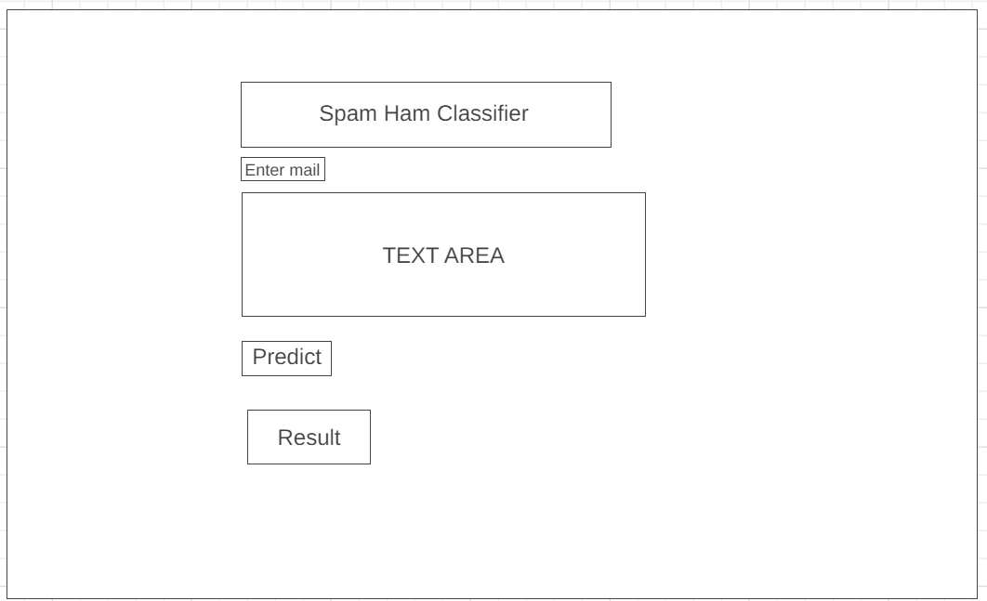

**3. Navigation Flow**

**1. User opens the app:** The header, text input area, and predict button are visible.

**2. User enters text**: Inputs the SMS or email text into the text area.

**3. User clicks 'Predict':** The app processes the input and displays the result below the button.

**4. Result Display:** The result (Spam or Not Spam) is shown in a bold, color-coded format.